**Health & Safety Talk**

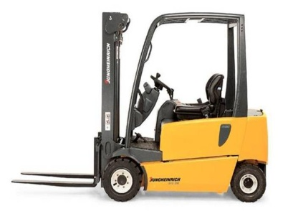**Forklifts**

Forklifts can be one of the most dangerous pieces of equipment in the workplace and are responsible for a number of deaths across Victorian workplaces.

**What are the risks?**

* Pedestrians being struck
* Forklift operators being crushed by the forklift (due to tipping over)
* Forklift operators or others being crushed by a falling load due to improper loading
* People falling from a height when standing on pallets or containers

**What should be done?**

* Be aware of operating forklifts around the workshop.
* Perform daily pre-operational checks prior to operating the forklift.
* Inform management if a forklift is past it’s servicing due by date (must be serviced annually).
* Only staff with a **current** forklift license (photo licence) are allowed to operate a forklift. Operators should always carry their licence on them.
* Seatbelts must be worn at all times when operating a forklift.
* Operators should make use of the horn and flashing lights when entering and exiting the workshop.
* Do not carry any passengers unless there is a passenger seat or a certified man up cage.
* Remove keys from the ignition when the forklift is not in use and left unattended. Store the keys in a safe location.
* Ensure that any damage/faults are reported to the manager. Lock out tag out the forklift until damage/fault is rectified.

**Who is responsible?**

Everyone is responsible for the safe use of equipment and following business procedures for the safe use of plant.

|  |  |
| --- | --- |
| **Consultation** |  |

**Date of Meeting:**_____________________

**Attendees** (list attendees present)

|  |
| --- |
|  |

**Items Discussed**

|  |
| --- |
|  |

**Action Items**

|  |
| --- |
|  |

**Management Sign Off**

**Name:** _______________________________________

**Sign:** ___________________________________ **Date:** ______________________________